Test for developers



|  |  |  |  |
| --- | --- | --- | --- |
| Name: | Jimmy Andres Mendieta Rivera | Date: | 19/06/2023 |

We are from "ST Genetics", and we would like to build a Web API where our customers can create, edit, delete, filter, and buy bulls or cows from our farms.

You are responsible for building the backend and the business rules are listed below:

* **Animal and Order Record – SQL Server**

Animal Table – (All columns are mandatory)

- AnimalId /Name / Breed / BirthDate / Sex (Male/Female) / Price / Status (Active/Inactive).

Create Database

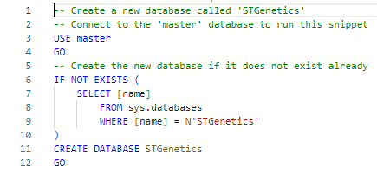

Create Table: Animals

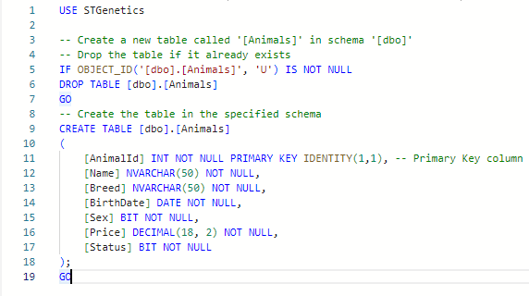

Create Table Customers

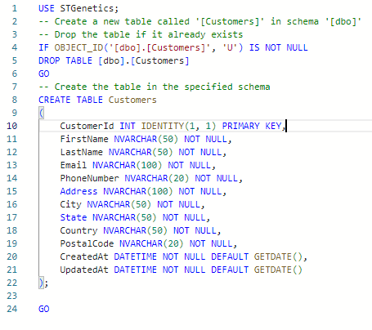

Create Table Orders

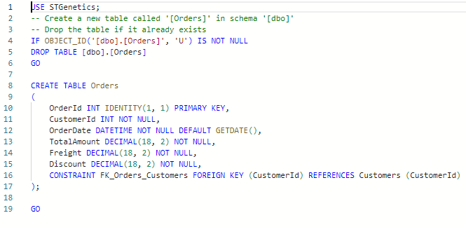

Create Table OrderDetails

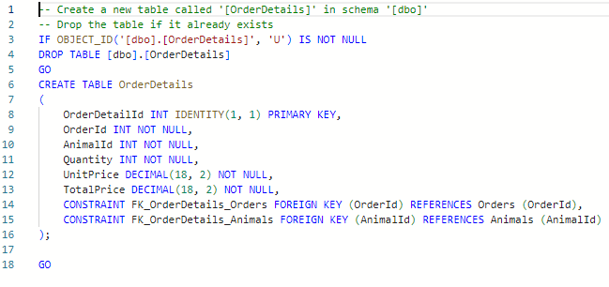

**Requirements:**

1. Create the "STGenetics" database.



1. Create a script to create Animal table.



1. Create a script (Insert / Update / Delete) for record in Animal table.

Insert Animal Script

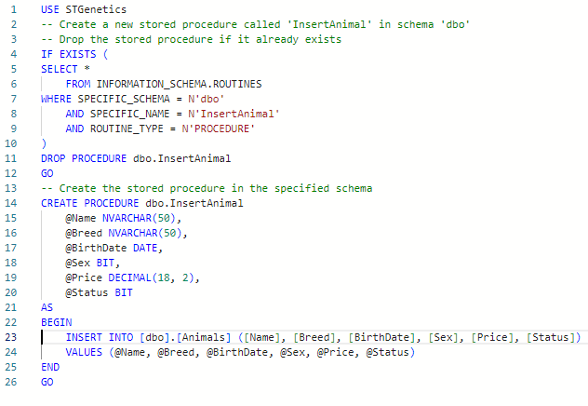

Update Animal Script

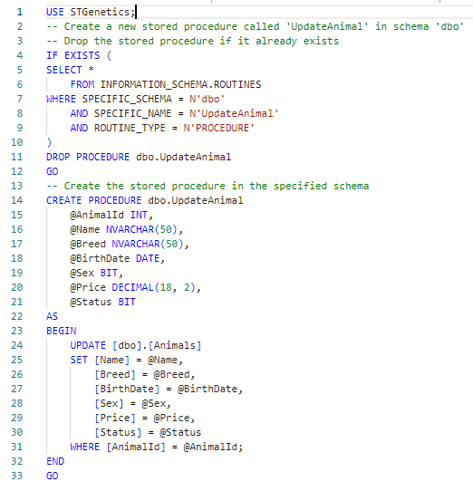

Delete Animal Script

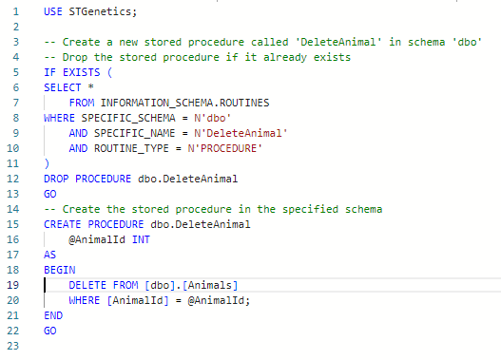

1. Create a script to insert 5,000 animals in the Animal table.

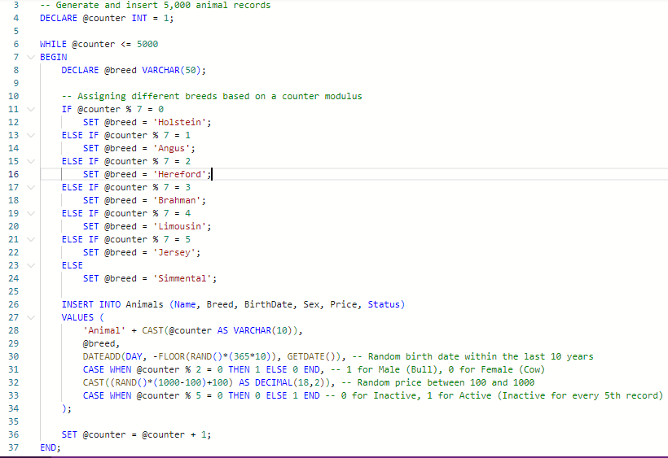

1. Create a script to list animals older than 2 years and female, sorted by name.

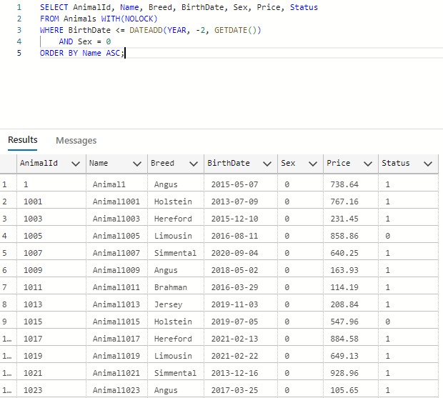

1. Create a script to list the quantity of animals by sex.

* **Web API**

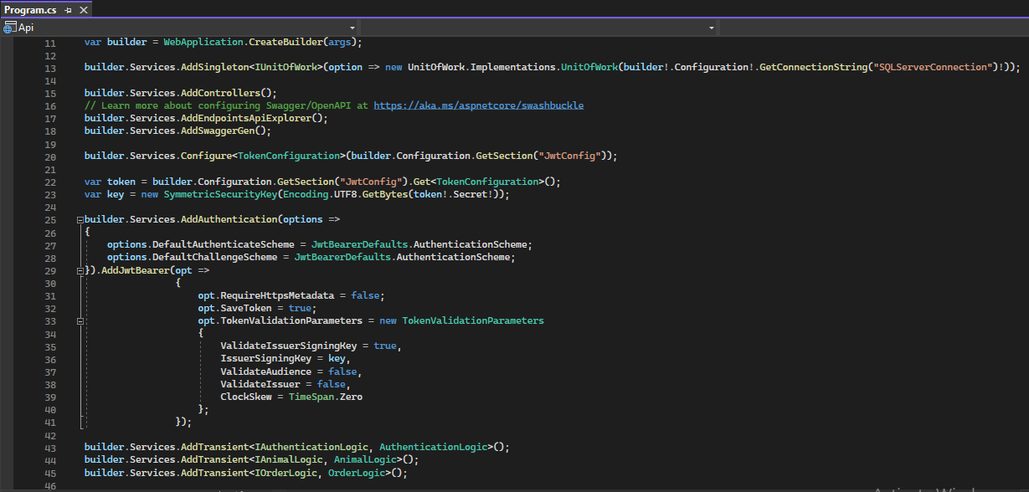

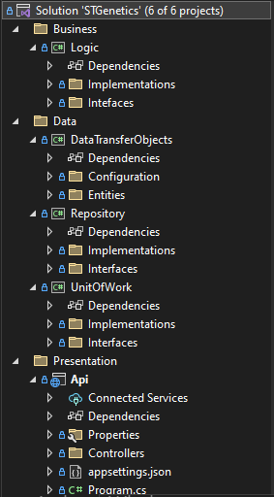

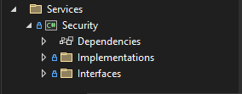

* **Endpoint Create Animal:**
  + Create an endpoint to save animals to the Animal table.

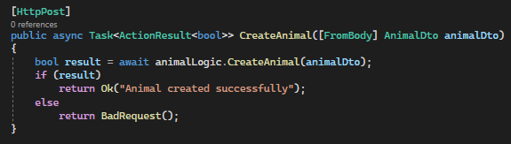

* **Endpoint Update Animal:**
  + Create an endpoint to edit an animal by AnimalId.

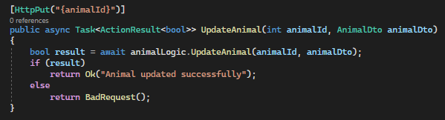

* **Endpoint Delete Animal:**
  + Create an endpoint to delete an animal by AnimalId.

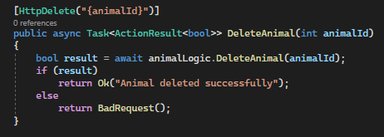

* **Endpoint Filter Animals:**
  + Create an endpoint that filters animals by AnimalId or Name or Sex or Status (Active or Inactive).

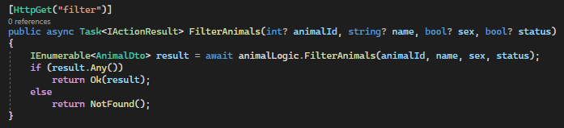

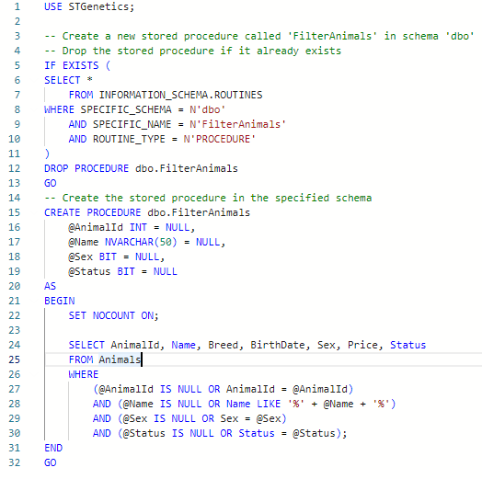

* **Endpoint Order:**
  + This endpoint should save an animal purchase in the Table and return a Json informing the Id and the total purchase amount.

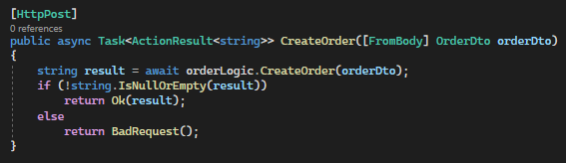

* + **Business Rules:**
    - If the customer adds an animal with a quantity greater than 50 in the cart, we must apply a 5% discount on the value of this animal.

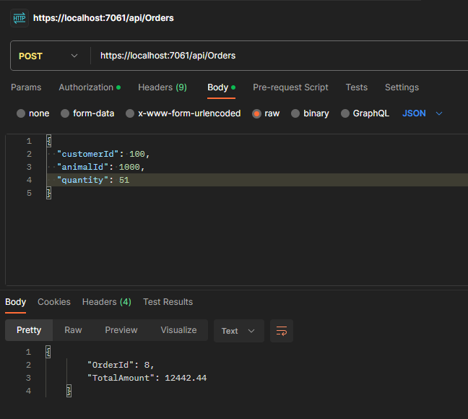

* + - If the customer buys more than 200 animals in the order, an additional 3% discount will be added to the total purchase price.

* + - If the customer buys more than 300 animals in the order, the freight value must be free, otherwise it will charge $1,000.00 for freight.

* + - It is not allowed to duplicate the animal in the Order. If you identify the duplicate animal, the API should return an error message displaying the reason.

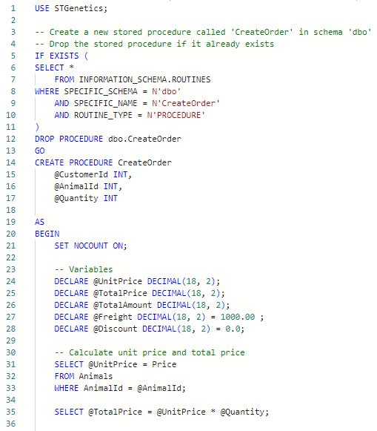

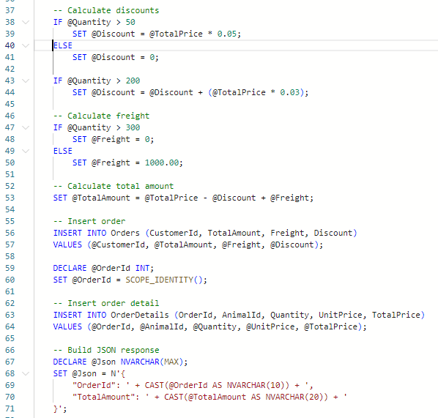

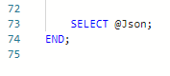

* + **Database:**
    - The database (tables and scripts) necessary for the Web API to be created by you according to your needs.
* All endpoints need JSON Web Token (JWT) authentication.

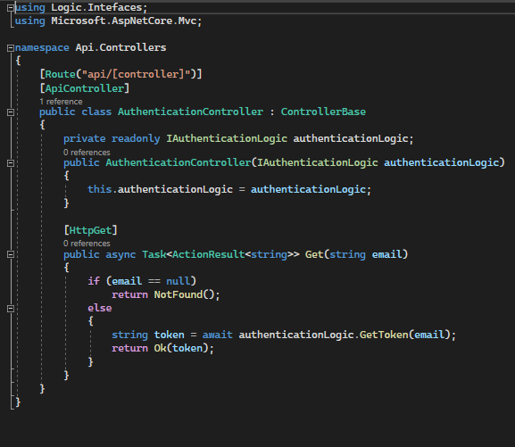

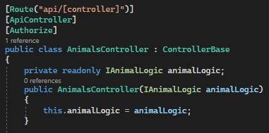

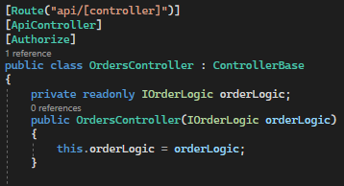

**Requirements:**

1. The Web API needs to be in the C# programming language using the .Net 6 or .Net 7 frameworks.

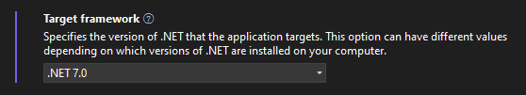

**Differentials:**

1. Using the Micro ORM Dapper is a plus.

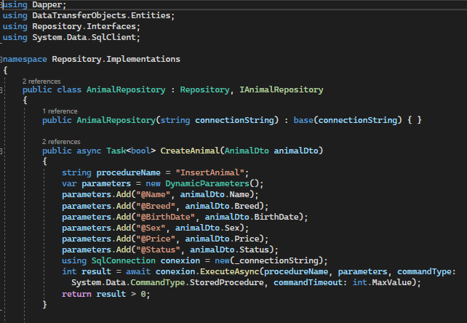

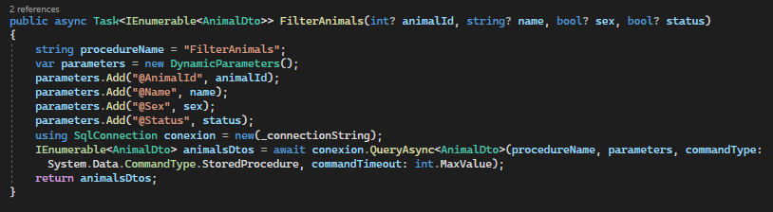

1. All endpoints using async/await.

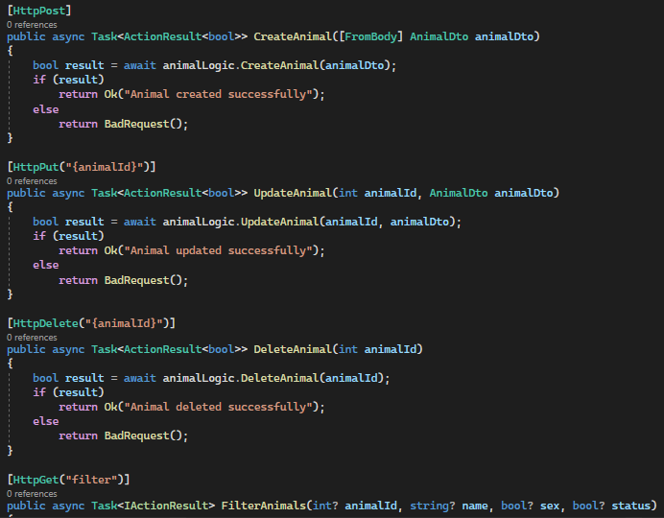

1. Clean code without Warnings when compiling.

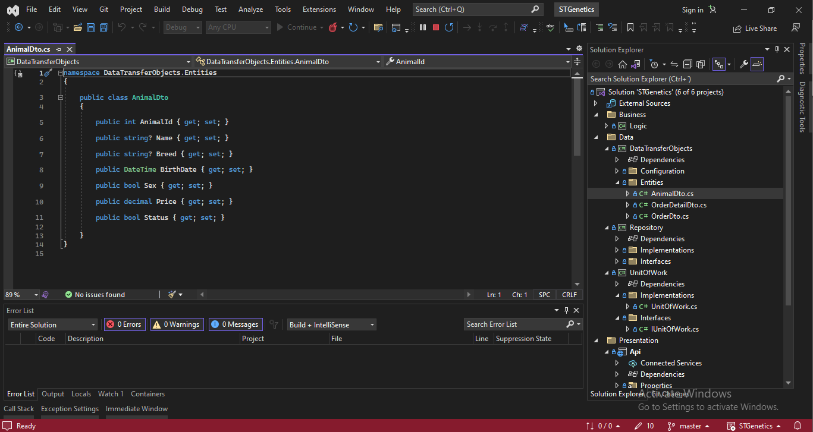

* **Observations:**
  + All requests/tests will be done using the postman or swagger.

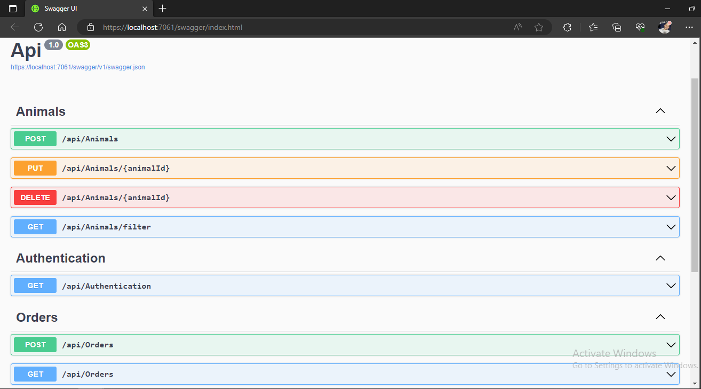

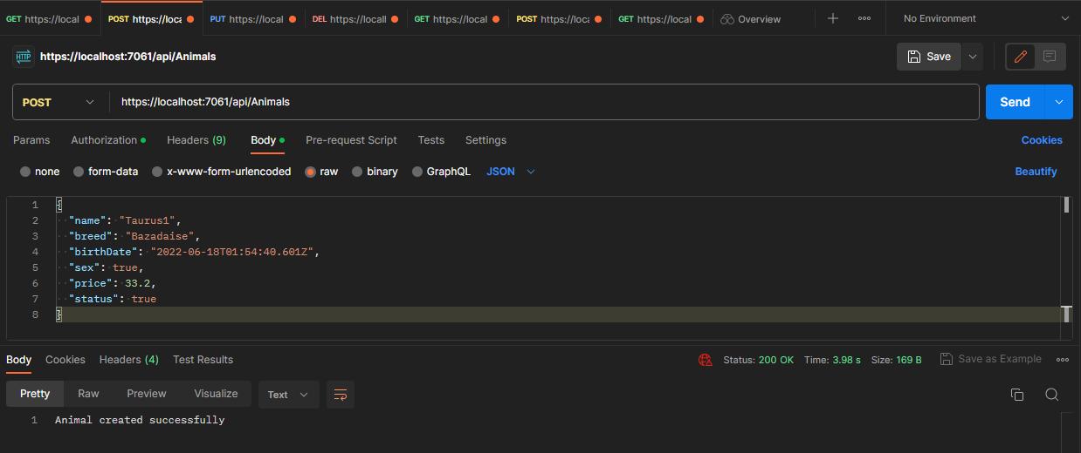

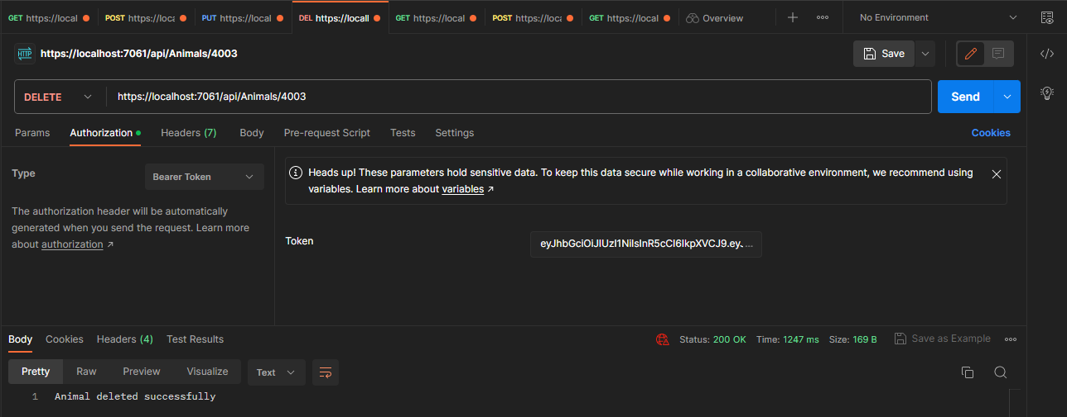

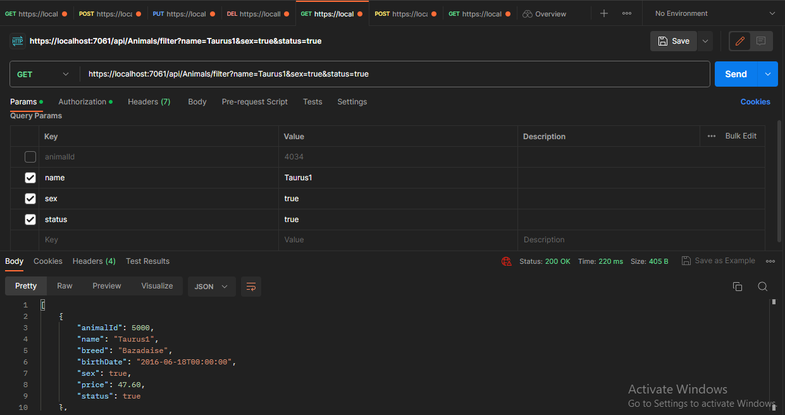

* + Use local database (SQL Server).

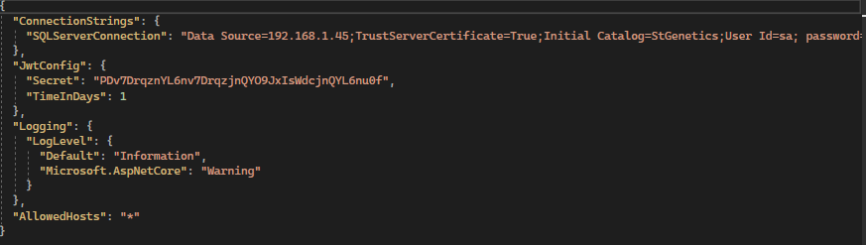

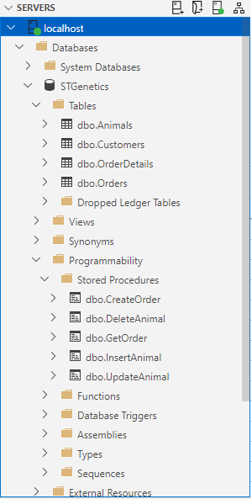

* + The final project needs to be made available on GitHub or sent by email.

[jamendieta/STGenetics (github.com)](https://github.com/jamendieta/STGenetics)